Online Course Electricity_bill(Select queries)

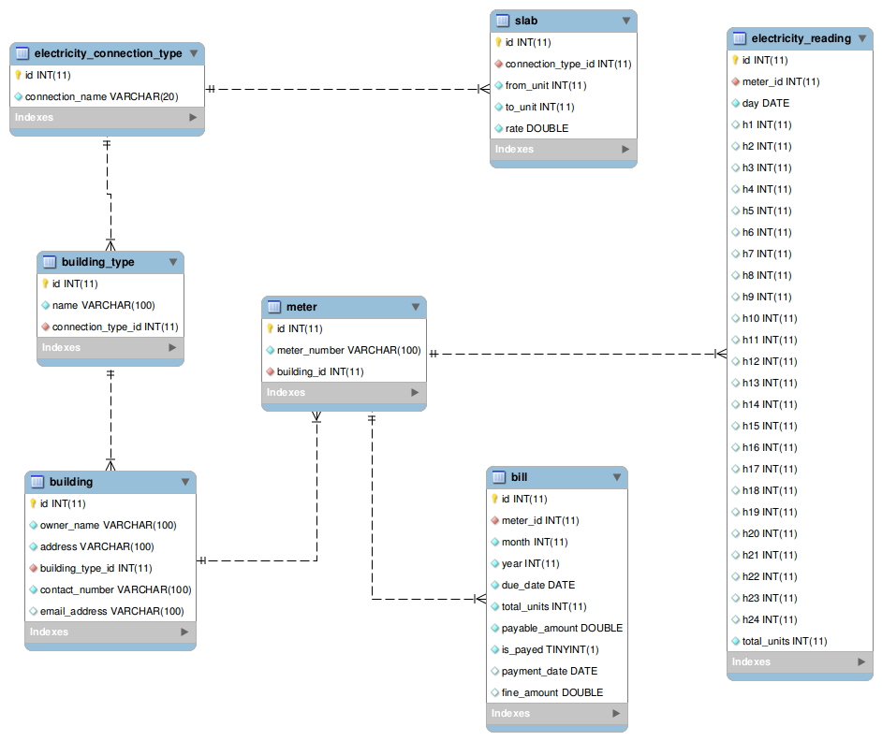

Queries:-

1. Write a query to display the entire contents of the 'electricity_connection_type'.Display the records in ascending order based on their connection name.
2. Write a query to display the entire contents of the building_type table, sorted by name in ascending order.
3. Write a query to display the entire contents of the 'building'.Display the records in ascending order based on owner name.
4. Write a query to display the entire contents of the  'electricity_reading', Display the records in descending order based on 'total_units'.
5. Write a query to display all 'meter_number' from meter table.
6. Write a query to display the owner_name and contact_number of all building, Display the records in ascending order based on owner_name.
7. Write a query to display the **total_units**, **payable_amount**, **fine_amount** of all **bills** , sorted by **total_units** in descending order.
8. Write a query to display the entire contents of the slab table, sorted by from_unit in ascending order.
9. Write a query to display the details of the **building** whose owner_name is **'Nicholas'.**
10. Write a query to display the details of all the bills whose 'total_units' greater than 10000, sorted by total_units in descending order.
11. Write a query to display the details of all the bills with the due_date on '2017-10-01', sorted by payable_amount in descending order.
12. Write a query to display the owner_name, address and contact_number of the buildings which does not have an email_address, sorted by owner_name in ascending order.
13. Write a query to display the entire details of the building whose owner_name starts with the letter 'M', sorted by owner_name in ascending order.
14. Write a query to display the entire details of the building whose building_type_id is 2, sorted by owner_name in ascending order.
15. Write a query to display the details of the electricity_reading whose total_units per day is between 500 and 1000, sorted by total_units in ascending order.
16. Write a query to display the meter_id and total_units of electricity_reading whose 13th hour reading is lesser than the 14th hour reading, sorted by total_units in descending order.